APPENDIX A

ITS61504

Data Mining

Group Assignment (40%)
Semester April 2026

Name (Block Capital) | Registration No. | Signature | Marks  (For Lecturer Use)
1.Li Zhe | 0370716 | 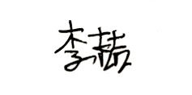
2. Liu Yifan | 0374114 | 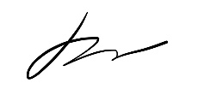
3. Gu Sijia | 0365826 | 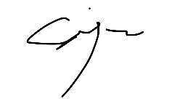

I declare that:
- I understand what is meant by plagiarism
- The implication of plagiarism has been explained to us by our lecturer. This project is all our work, and I have acknowledged any use of the published or unpublished works of other people.

